24.18: 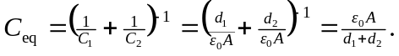 So the combined capacitance for two capacitors in series is the same as that for a capacitor of area A and separation 

